As Published in the Putnam County Times August 19, 2015

Preserving the Past
By Tom Maxson

Save the Historic Hill-Agor Farm

There’s a great deal of talk here in Putnam County when it comes to preserving history and promoting heritage tourism, an over $5 billion industry here in New York State. But the true test comes when an extremely important historic asset is being threatened.

The Hill-Agor Farm is one of the most important historic sites in Putnam County, among all of the remarkable historic sites in our County. Located in Mahopac Falls on Hill Street, Anthony Hill purchased this property around 1740 from the Native Americans who had considered, what is now Putnam County, as part of their ancestral homeland. Anthony’s son, the patriot Captain William Hill, fought in both the French and Indian War and our War for Independence. Five of his sons, Noah, Stephen, William Jr., Cornelius, and Abraham, also served as patriots in the Dutchess County Militia during the Revolution.

Many of these patriots and their families are buried in the Hill Cemetery located in the front of the farm.

In the early 1830s, this farm was the subject of an extremely important Supreme Court case during Chief Justice John Marshall’s tenure, which resulted in defining the scope of the court’s jurisdiction, recognizing valid land sales and purchases by the tenant farmers in the 1700s, and protecting land owners from having their properties unfairly seized by the wealthiest man in America at that time, John Jacob Astor. This ruling is as important today as it was in the 1830s.

As explained by Allan Warnecke, the former Putnam County and Town of Carmel Historian, in 1854 a land swap was negotiated between Thomas Hill and Abijah Smith. Smith’s granddaughter and her husband, Kelsie Agor, and their descendants, then made the farm their home.

Putnam County has owned this property since 2003. In 2004-2005, the original application for the National Register of Historic Places was prepared and submitted to the New York State Historic Preservation Office (SHPO). That office indicated that the property would certainly be eligible for the Register. If this property were placed on the Register, it would then become eligible for grant funding from State, Federal, and private sources. It would also enhance the property and promote heritage tourism. The former Mahopac Airport property, located behind the farm to the east, was leased to the Town of Carmel for $1 per year. The Town then granted the Mahopac Sports Association (MSA) the right to use the old airport for use as soccer fields.

Unfortunately, the process of allowing the farm to be placed on the National Register was then halted by a single phone call to SHPO from a now former legislator, without any vote being taken by the full legislature on this matter.

In June of 2011, County Executive Paul Eldridge brokered an agreement to allow the National Register application to proceed. That agreement included the MSA, the Town of Carmel, and the historic preservationists. In December of that year, the full Legislature unanimously passed 2 resolutions: Resolution #348 approved the designation of the farm as a Preserve America site; and the second Resolution, #349, to move forward with an application for the National Register, based on the agreement that was brokered by County Executive Eldridge. But again, the process was derailed when one party decided to back out of the agreement. The entire issue has been held hostage ever since.
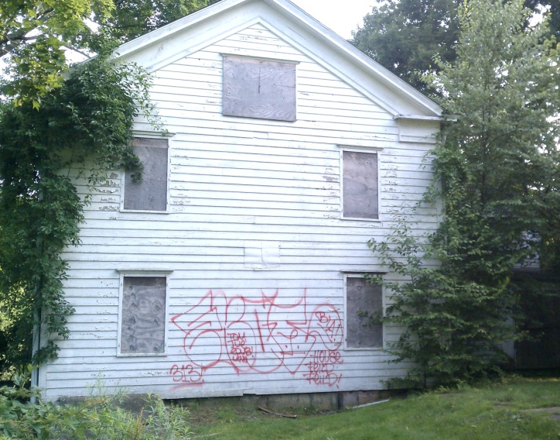
Today, the 1843 Greek Revival-style farmhouse is suffering from the ravages of nature and vandalism. It has become the victim of destruction through neglect. Over the past 10 years, the farm has been attacked not just by miscreant youths, but also by adults who should know better. A barn and stone wall were destroyed in one New Years Eve rampage by those adults using heavy machinery in the dead of night. Where were our County and Carmel Town officials then?

Vandalized Hill-Agor Farmhouse (Tom Maxson)

The SHPO is ready to proceed with the application. No one is seeking to restrict access to the fields for the MSA; in fact, there are several alternatives that exist for that. There is also a County-owned property, next to the Austin Road School, which would be suitable as an alternative to the airport fields.

This does not require a single penny from Putnam County. But the Physical Services Committee and the legislature need to help stop this destruction by allowing the Hill-Agor National Register application to proceed in order to reverse the deterioration of this very important historic site, and preserve it for future generations. It’s time for the Town of Carmel and the MSA to step up, and for Putnam County to serve as a good steward of this historic property.

For information on upcoming free Magical History Tours, please check our facebook page (“Highlands Historic Preservation”), visit our website at HighlandsPreservation.org, email thomasmaxson@HighlandsPreservation.org, or call (845) 249-8880.

