Preserving the Past
By Tom Maxson

Vandalism and Stolen Valor

In response to an article that appeared in the February 3, 2016 edition of this newspaper (“A Little About KEPRI . . .”), while I was down south awaiting the arrival of our granddaughter into the world, one of the primary missions of historic preservationists is to protect the integrity of archaeological sites. We are blessed with a number of such sites here in Putnam County.

The New York State Office of Parks, Recreation, and Historic Preservation (NYS OPRHP), has stated: “Once archeological material has been removed from the ground, whether through excavation or as a result of looting, development, erosion, or other processes, the site is destroyed forever. When sites are excavated improperly, information is lost and the value of the archeological deposits is greatly diminished. Unauthorized excavation and removal of materials from any of these sites is prohibited.”

But as in all walks of life, there are the few who feel they are above the rules. One such local character is “Dr.” Philip Imbrogno. Imbrogno’s website stated he held a doctoral degree from MIT in Theoretical Chemistry, and undergraduate degrees in Astrophysics from the University of Texas. He also stated that he had served in the Vietnam War as a Special Forces Green Beret officer.

Imbrogno once planted what he claimed to be an obsidian knife inside the “King’s Chamber”, the largest known stone chamber in Putnam County. He then tried to use this “find” to support his theory that the chambers were built by the ancient Celts 1,000 years ago. The knife then mysteriously disappeared before it could be inspected for dating purposes.

In April of 2010, Imbrogno solicited his followers via email to “raise the stones on Beltane”, a Celtic fertility holiday celebrated on May 1st. He asked them to bring rope and shovels to move some of the stones around the stone chambers in Whang Hollow and Mt. Nimham in Kent to make them appear to be Celtic temples. These registered archaeological sites were located on New York City and New York State properties. Luckily, the preservationists’ threats of calling law enforcement authorities forced Imbrogno to abandon his scheme.

And as it turns out, Imbrogno never even attended MIT nor the University of Texas, per the findings of Lance Moody. But even worse than his academic fraud, Imbrogno had also lied about his military service, when he claimed to have served as a Green Beret Special Forces officer in Vietnam, according to the research conducted by Don Ecker and Kevin Randle, an army veteran who served in Iraq. This “stolen valor”, as it is known, is considered one of the most heinous acts of fraud. It demeans the sacrifice made by our real heroes who have served, and especially for those who have made the ultimate sacrifice for our country. After word of his fraud became known, Imbrogno dropped out of sight.

Imbrogno’s protégé, Renee J. Fleury, stated on her original website that her organization could not have existed without the help of Phil Imbrogno. “Phil's research and knowledge has guided KEPRI and given us our start,” she stated. In 2010, she told a group in Brewster that it was alright for them to “dig around” on archaeological sites, a clear violation of State Historic Preservation law. She also offered tours “for a reasonable fee” in violation of DEC and DEP regulations.

Later in July, when Ms. Fleury painted graffiti on the historic Mt. Nimham fire tower, an extremely misguided town official reacted by covering over her graffiti, and only her graffiti, before the Kent Police could investigate. Ms. Fleury has denied that she ever had any involvement with the Kent Police. But per Kent Police report #2010-001407, Ms. Fleury was advised by them that “Further activity would be pursued criminally.” Is she accusing the Kent Police of lying?

That town official, who had a penchant for using religious slurs in his official emails, also shared the emails, informing him of the vandalism, with the vandals themselves, claiming he was obligated to do so under the Freedom of Information Law (FOIL). But when Robert Freeman, the head of the New York State Committee on Open Government, and the ultimate expert on FOIL, was asked for an advisory opinion, he rebuked the town’s position, stating that FOIL specifically excluded the sharing of information with criminal suspects. And the Commissioners of the DEP and DEC have written that, had they been made aware of these vandalism threats on their properties, they would have prosecuted those involved.

And what was Ms. Fleury’s reaction to Imbrogno’s fraud and stolen valor? She suggested that perhaps the government was persecuting Imbrogno because of his “invasive UFO research and exposure of the truth”.

According to the town steward’s public email of July 13, 2010, “She (Fleury) is a WCC graduate in Archeology.” But the Westchester Community College Registrar informed us that they do not offer any such program.

In 2015, Ms. Fleury advertised the opportunity to visit Native burial sites in the area. This exploitation violates the core of preservationist philosophy, and demeans the sacred nature of these sites. She also uses flammable liquid accelerants for her ceremonial fires in State forests, especially during the dry season, another violation of DEC rules, and poses a potentially dangerous practice.

Ms. Fleury has recently stated that “Nothing about the stone chambers is fact. Nothing. Anyone who tells you otherwise is full of crap.”

But she conveniently ignores a long historical record. Newspaper articles in the 1800s mention the building of root cellars at specific sites, where some of the stone chambers are found today. And one farmer was so proud of his creation that he etched his initials, and the year he built it, into the chamber itself. That was Amos C. Barger (1812-1888) of Putnam Valley, in 1832. A later relative, Lucas C. Barger (1866-1939), wrote a detailed account of how his family built these structures.

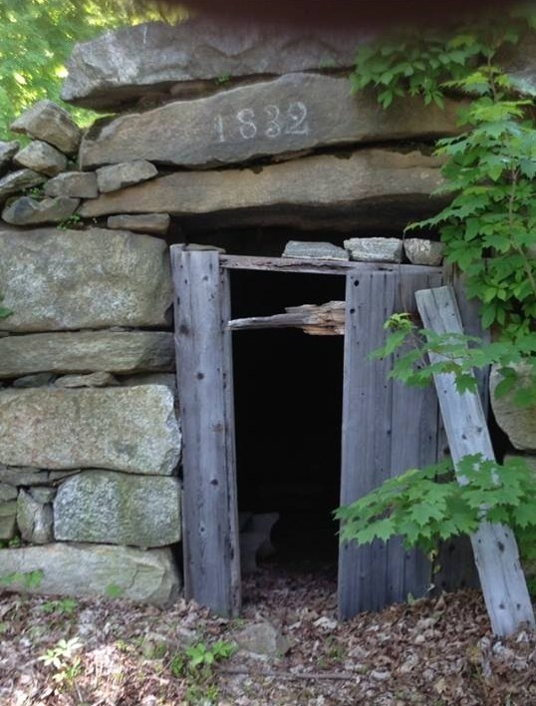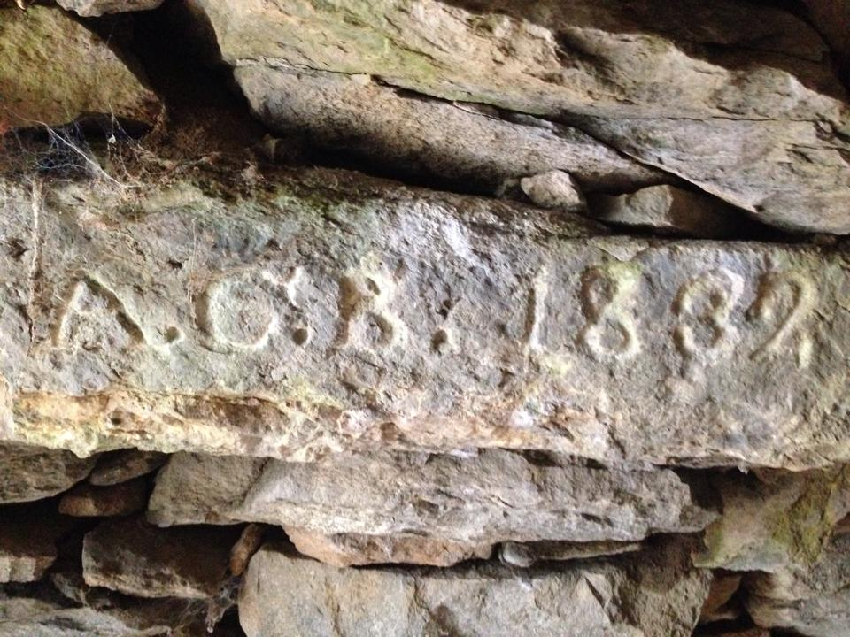
Amos C. Barger Root Cellar, Exterior and Interior (Photos By Russ Ciotti)

And where did the Bargers, and the other early settlers, come from? They came from England, Wales, Scotland and other such locales, and brought their root cellar building practices they had inherited from their ancestors here to Putnam County. This explains the similarity between our stone chambers and those found in the old country. The Imbrogno-Fleury belief that there is no historical basis for the early farmers building these structures, with absolutely no archaeological or historical evidence to support their belief, is intellectually dishonest.

Finally, those most negatively impacted by Ms. Fleury’s antics are the serious researchers, many of whom I’ve worked with, who are honestly attempting to study the possibility that some of the stone chambers are prehistoric. They’ve written that “We’re not sure that KEPRI realizes that by altering or intrusively ‘examining’ chambers they will make chambers invalid for further study. The sensationalism, book selling, digging up, and charging money for tours are similar to Phil Imbrogno’s tactics, and I am not sure they could be of any help in conserving the chambers.”

Amen!

