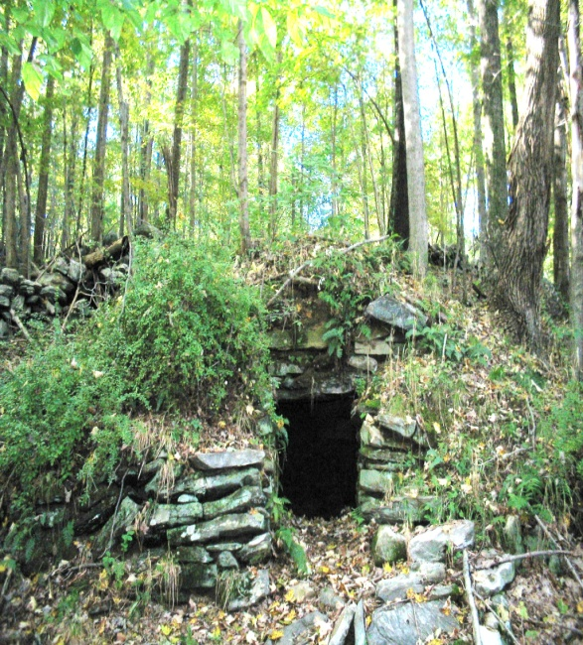

Highlands Preservation, Inc., a local non-profit volunteer organization, works to identify, research, protect and preserve our historical heritage. We work with the New York State Historic Preservation Office to include sensitive locations in the inventory of registered archaeological sites within New York. We also work with other preservationist organizations who share these goals. By being good stewards, we strive to ensure that these important remnants of our past are preserved for future generations to enjoy.

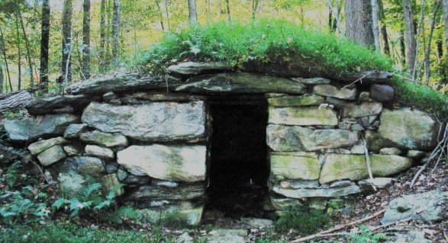Current Schedule
First Sunday of Each Month
April Through December

April 3, 11:00am: Hawk Rock, 2 colonial-era farm sites, & 3 stone chambers

May 1, 11:00am: Shaw’s Hill (California Hill), including 2 colonial-era farm sites
June 5, 11:00am: Hike to Parker Farm & Parker Cemetery

July 3, 11:00am: Mount Nimham: The Ridge of Patriots, including 2 colonial farm sites, stone chamber, & fire tower

August 7, 11:00am: Hawk Rock via southerly approach

September 4, 11:00am: Ultimate Mt. Nimham Stone Chambers Hike
October 2, 11:00am: White Pond loop
November 6, 11:00am: Wonder Lake

December 4, 11:00am: Old Roads Hike
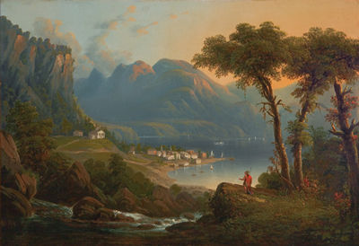

Highlands Preservation,
Inc.

(A Non-Profit Volunteer Organization)

Magical History Tours
&
Nature Hikes
(Free!)

2011 Schedule

www.HighlandsPreservation.org
Visit us on Facebook
thomasmaxson@HighlandsPreservation.org
(845) 249-8880
Kent, New York
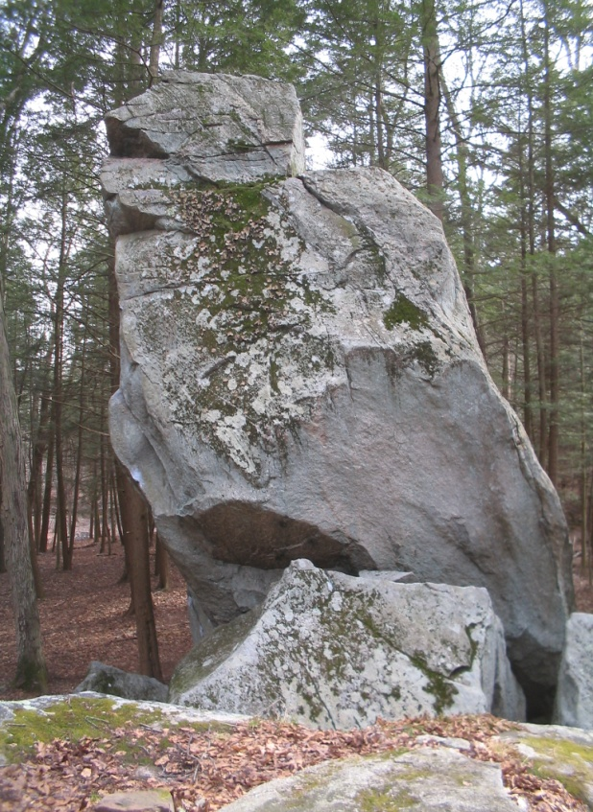
Join Highlands Historic Preservation and our associate sponsors, including the Kent Historical Society, as we take you on a monthly series of free hikes to the hidden and fascinating historic and prehistoric treasures in our own backyards. We’ll have local historians and naturalists on hand to provide the natural and human history of the areas we’ll be visiting. So get the kids off their computers, put your dog on the leash, and join us on these informative and invigorating walks through the hills and valleys of beautiful Putnam County.

Please check our website & Facebook page for hike details and updates.
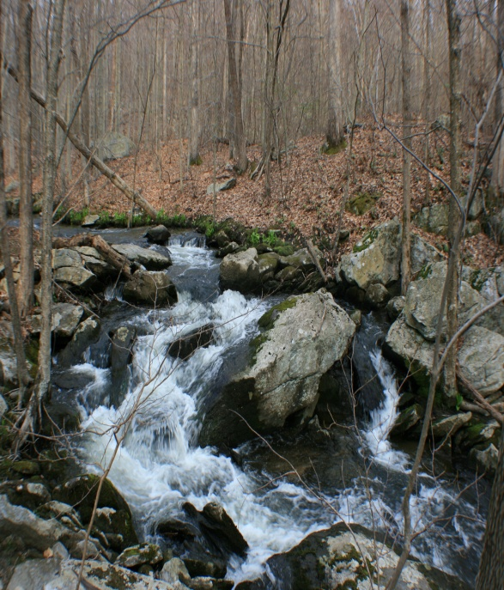

Our free Magical History Tours and Nature Hikes pass through some of the most beautiful open space areas in Putnam County. You’ll be amazed by the incredible rock formations, forested landscapes, and flowing waterways that make our home county such a desirable place to live. We are truly blessed to live in an area which would be considered by many to be a sought-after vacation destination. Come join your tour guides, Tom Maxson and Ed Illiano, and explore your own backyard with us!

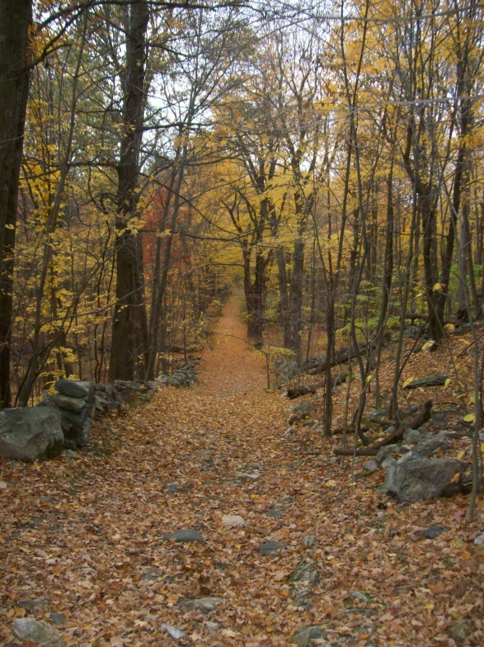

Many of our hikes include walks down the old roads, which are now trails in the woods. Some of these thorough-fares were originally Indian trails reused by the early farmers. Outlined by the stone fences built by the farmers, these beautiful passageways must be protected and preserved for future generations as well.

